**PROJECT 1:**

**VPC peering**

Ss: VPCs list- demovpc1 with private IP- 172.19.0.0/16

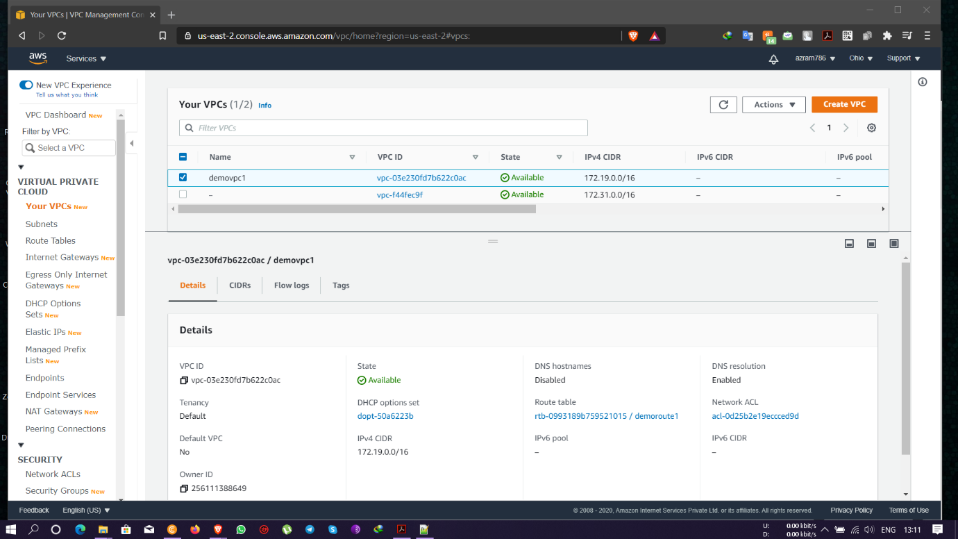

Ss: igw list- attached to demovpc1

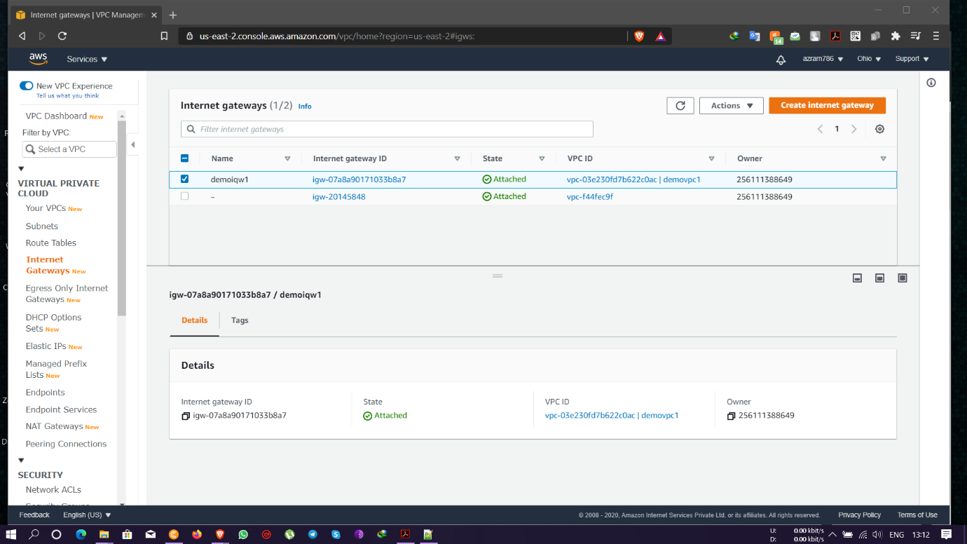

Ss: edit route list- demoroute1 and routed through demovpc1

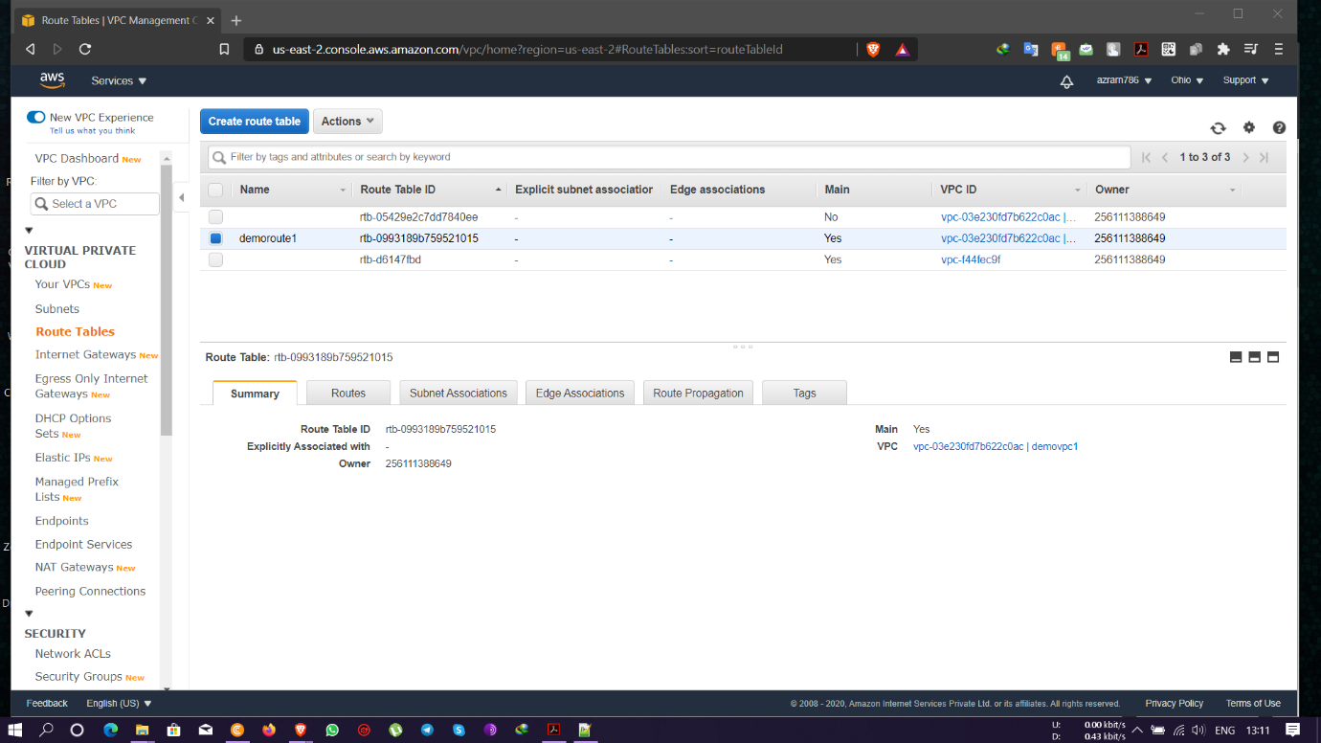

* Route added with 0.0.0.0/0 through IGW

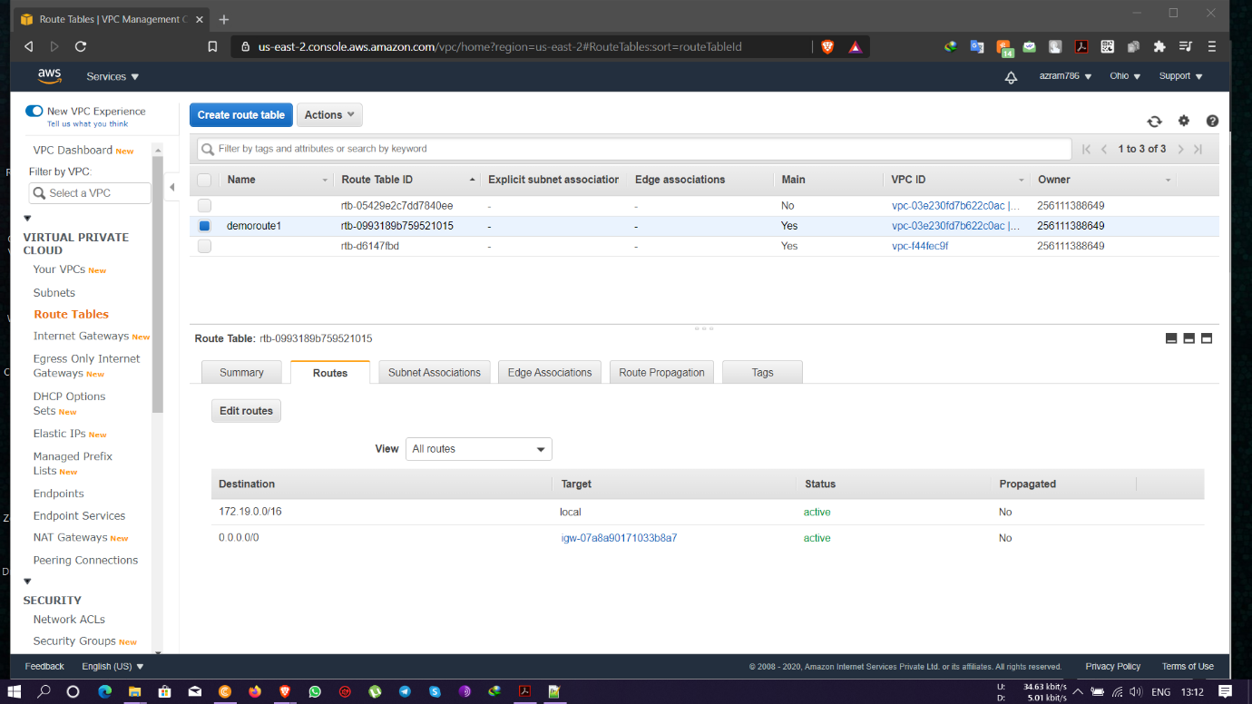

Ss: subnet list – with subnet IP- 172.19.19.0/24

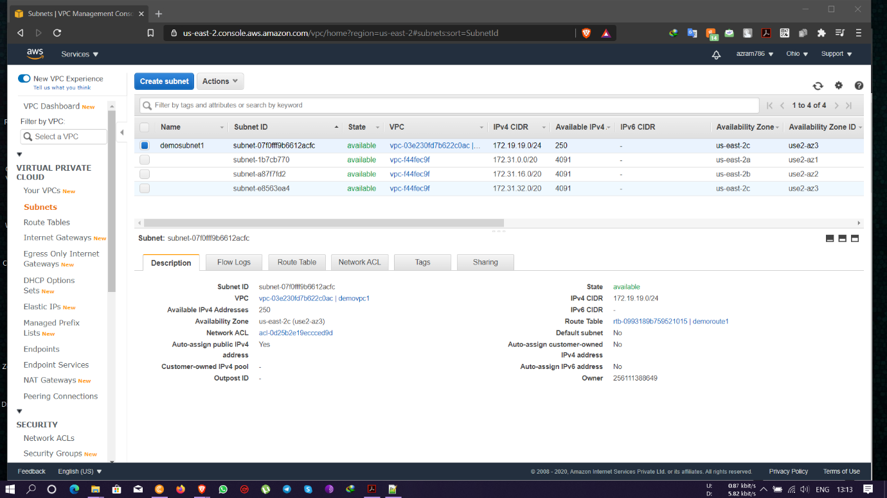

Ss: instance details- with public IP- 3.21.165.89

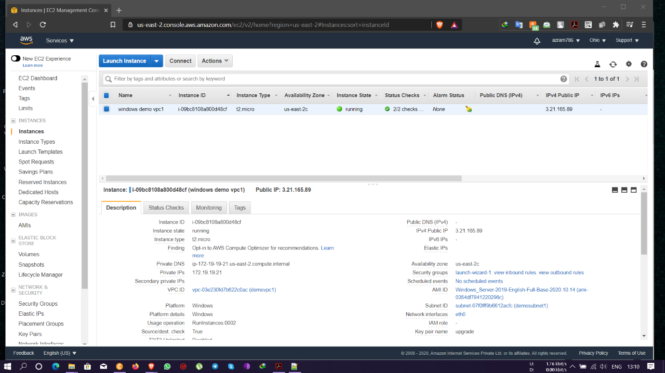

Ss: success pinging public IP -3.21.165.89 from personal PC

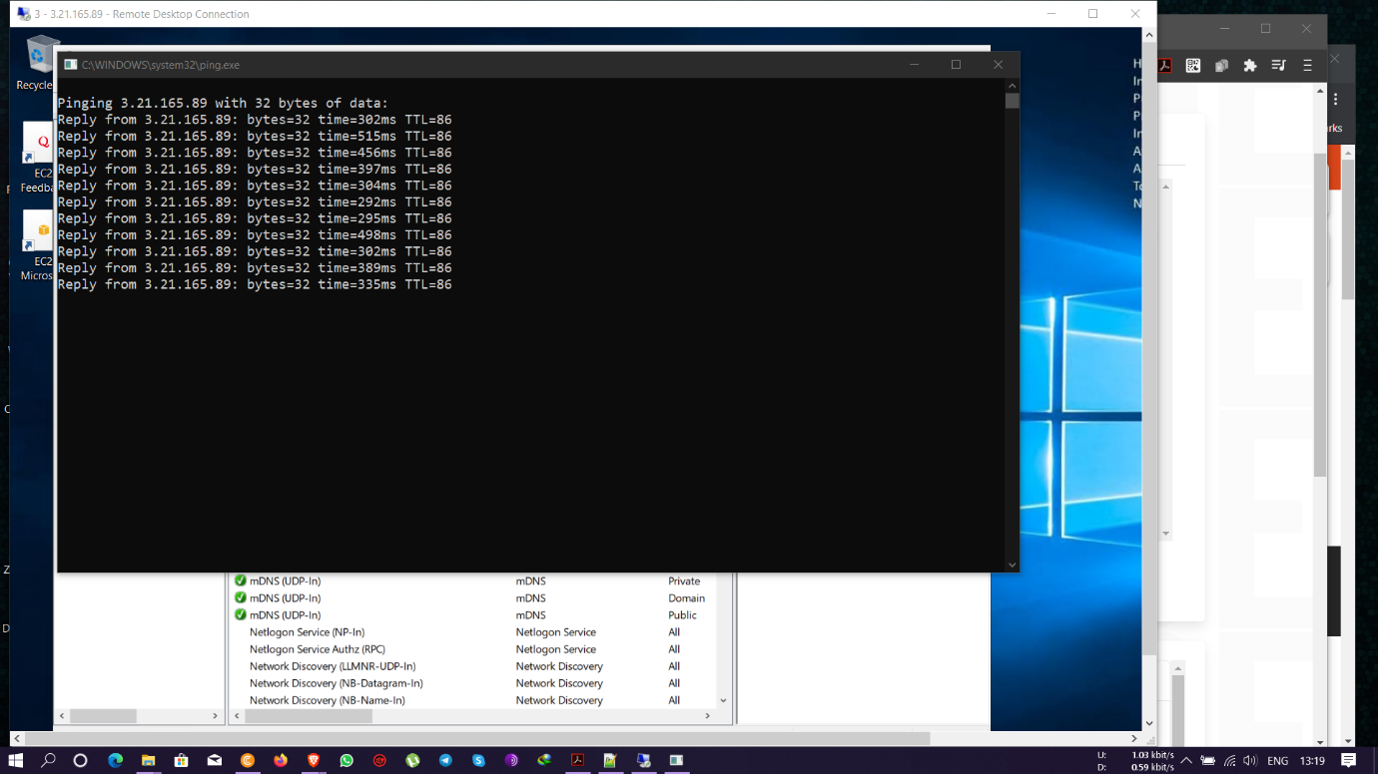

Ss: VPCs list – demovpc2 with private IP- 172.16.0.0/16

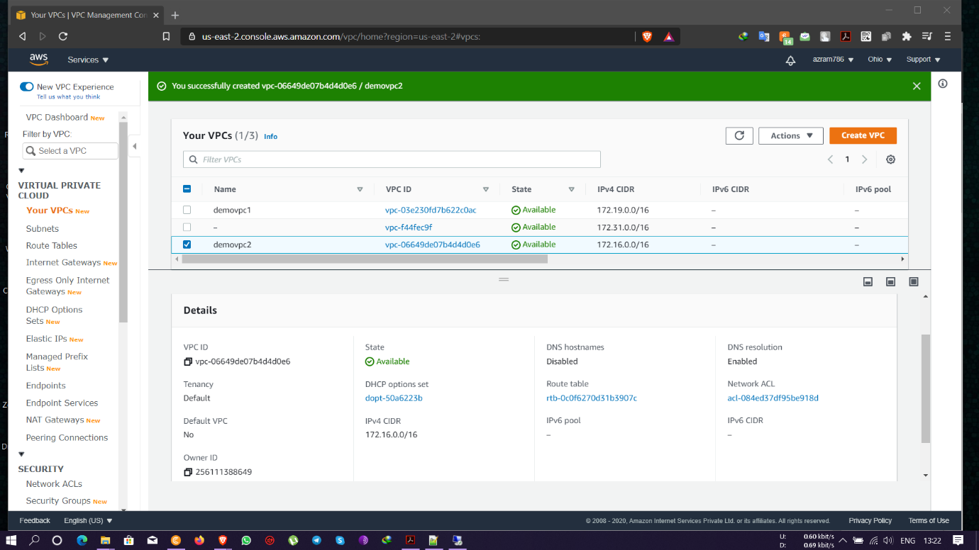

Ss: igw list- attached to demovpc2

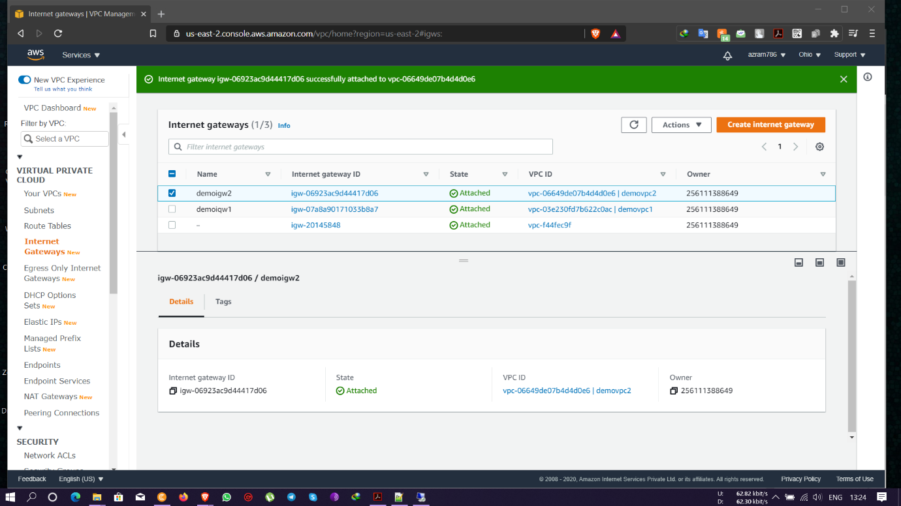

Ss: edit route list

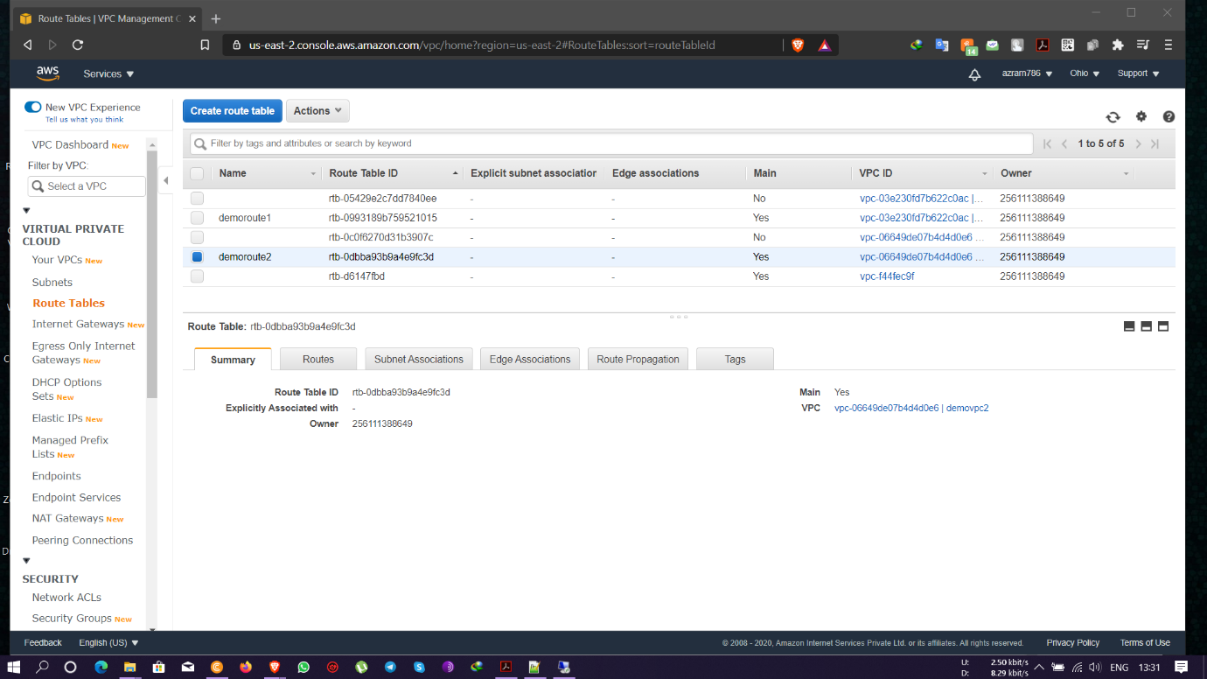

Ss: edit route list- demoroute2 and routed through demovpc2 and Route added with 0.0.0.0/0 through IGW

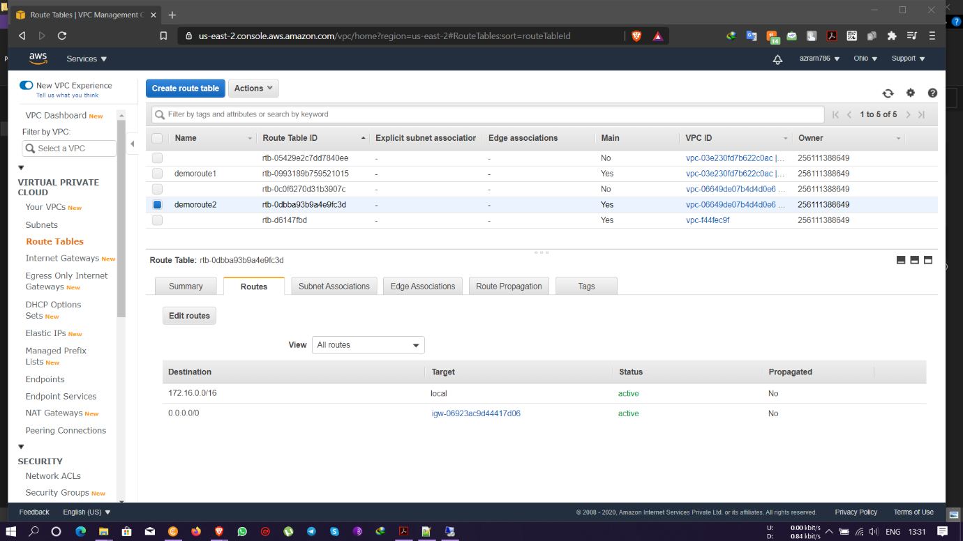

Ss: subnet list - with subnet IP- 172.16.16.0/24

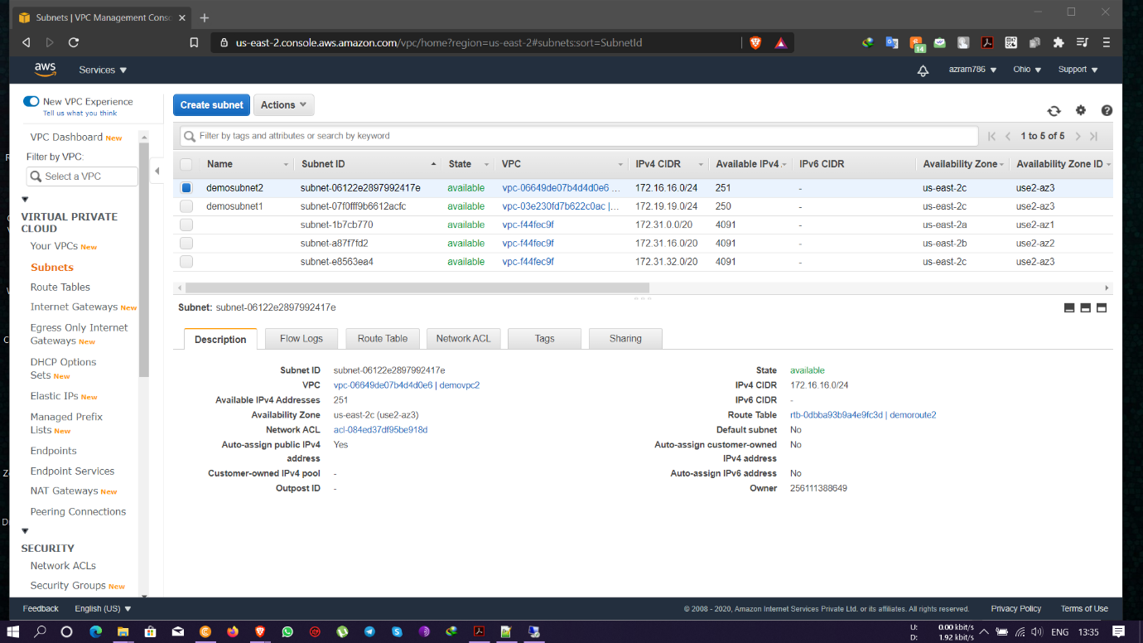

Ss: instance details- with public IP- 18.191.231.188

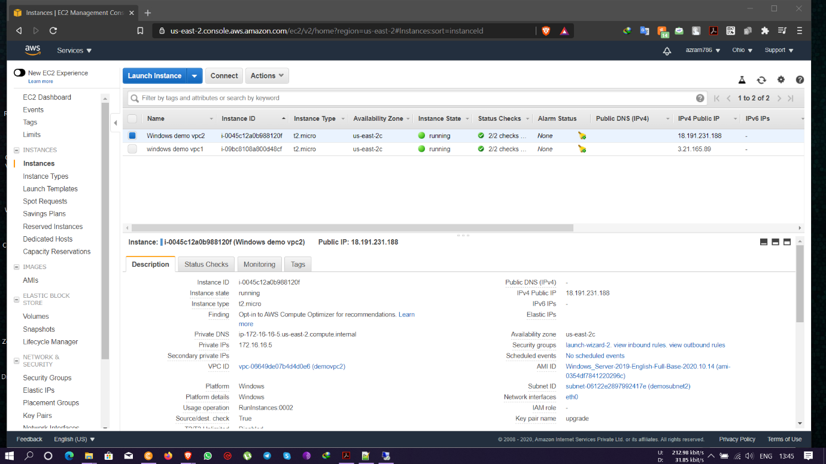

Ss: success pinging public IP -18.191.231.188 from personal PC

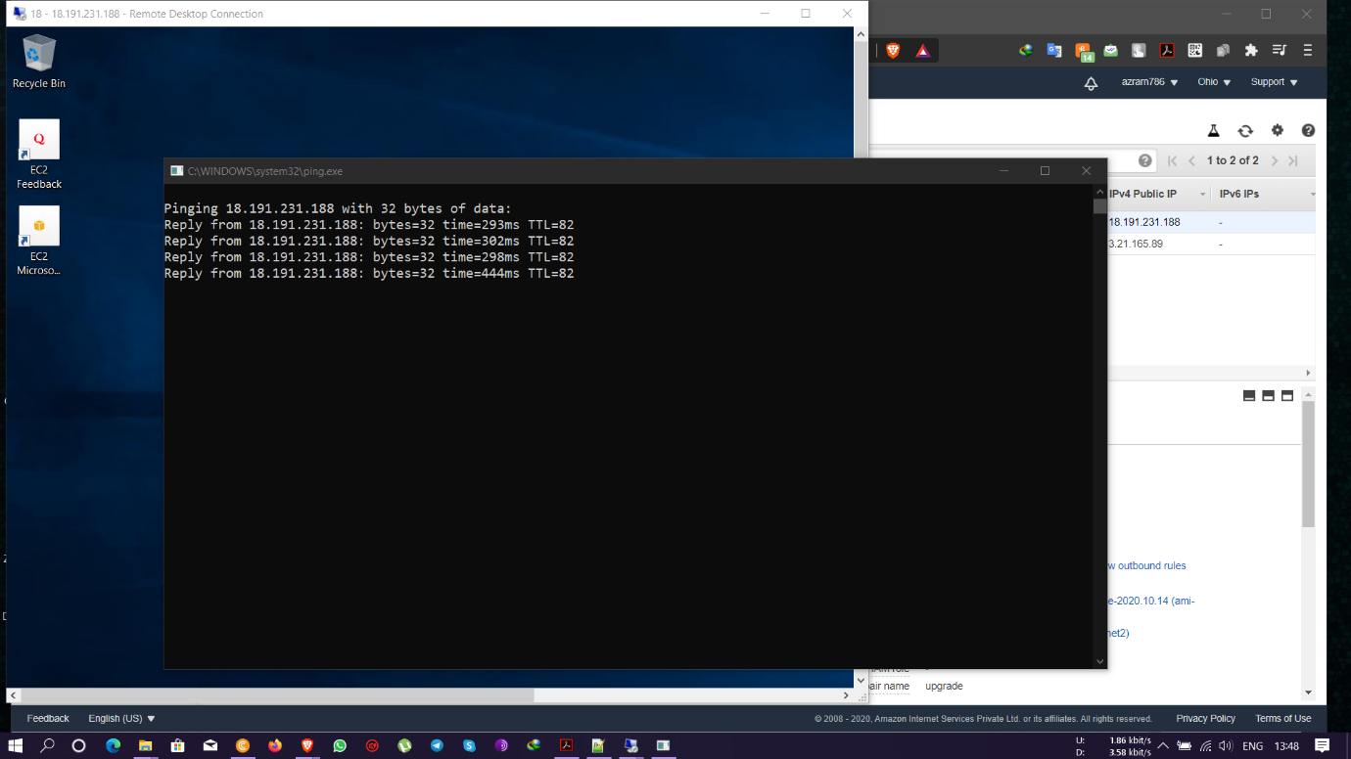

Ss: successful ping for public IP, private IP not reachable

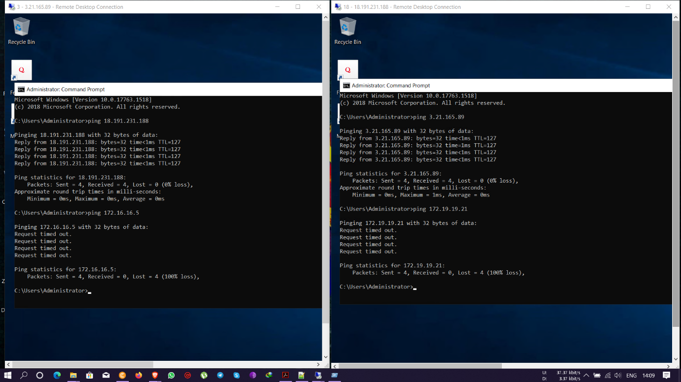

Ss: peering created with requestor and acceptor

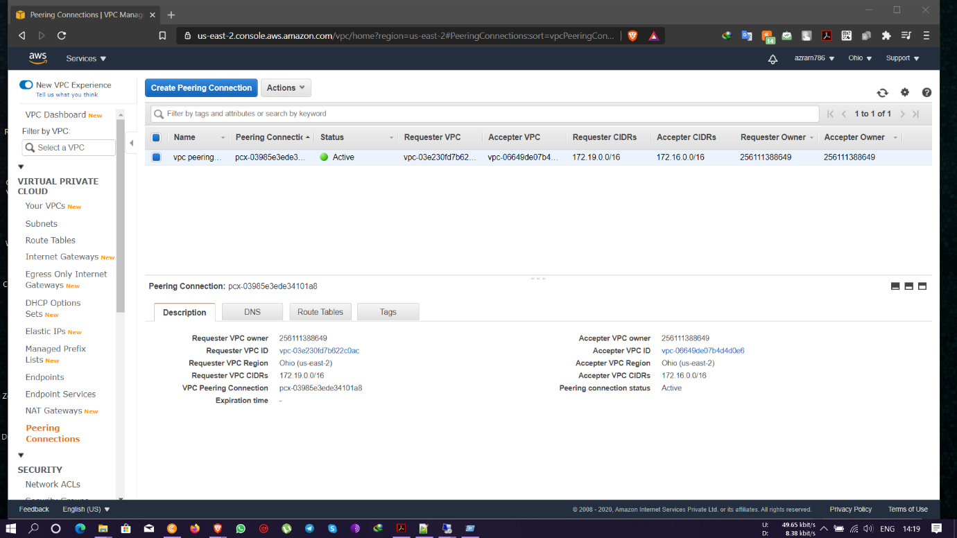

Ss: adding acceptor IP to receiver route table

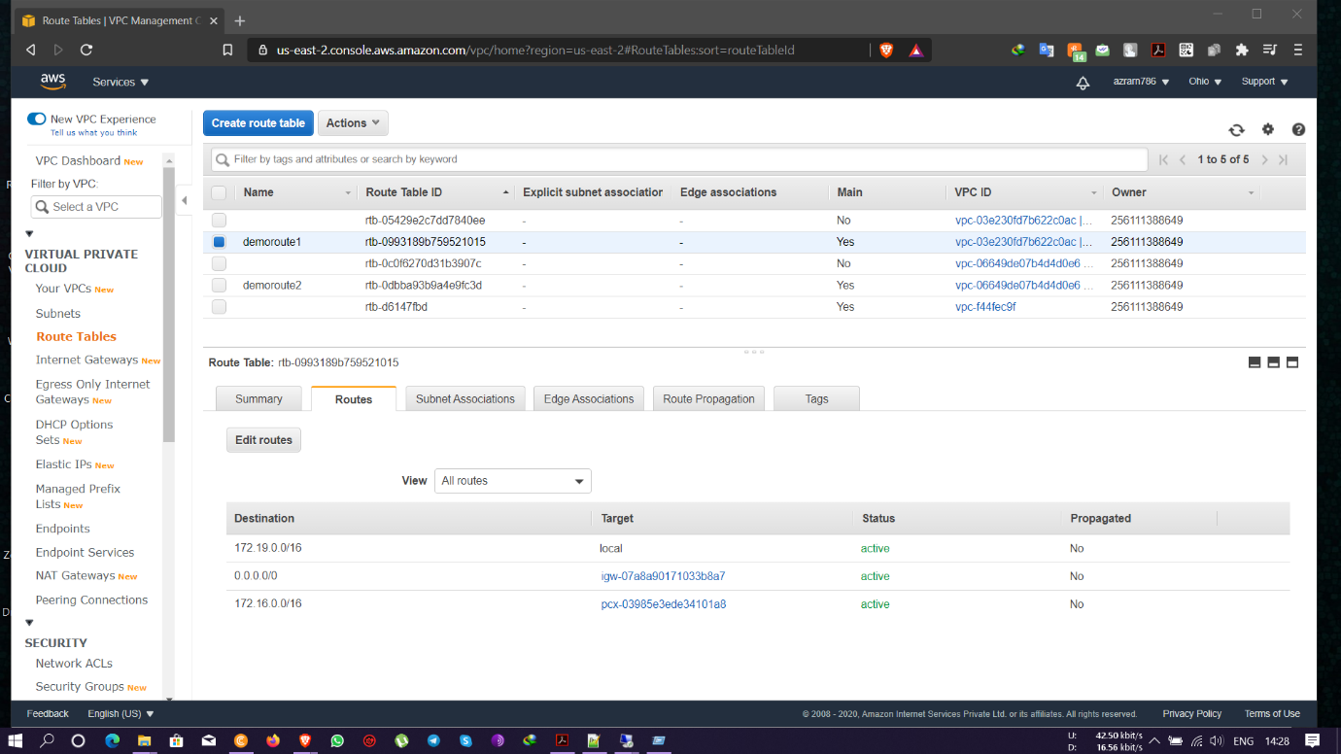

Ss: adding receiver IP to acceptor route table

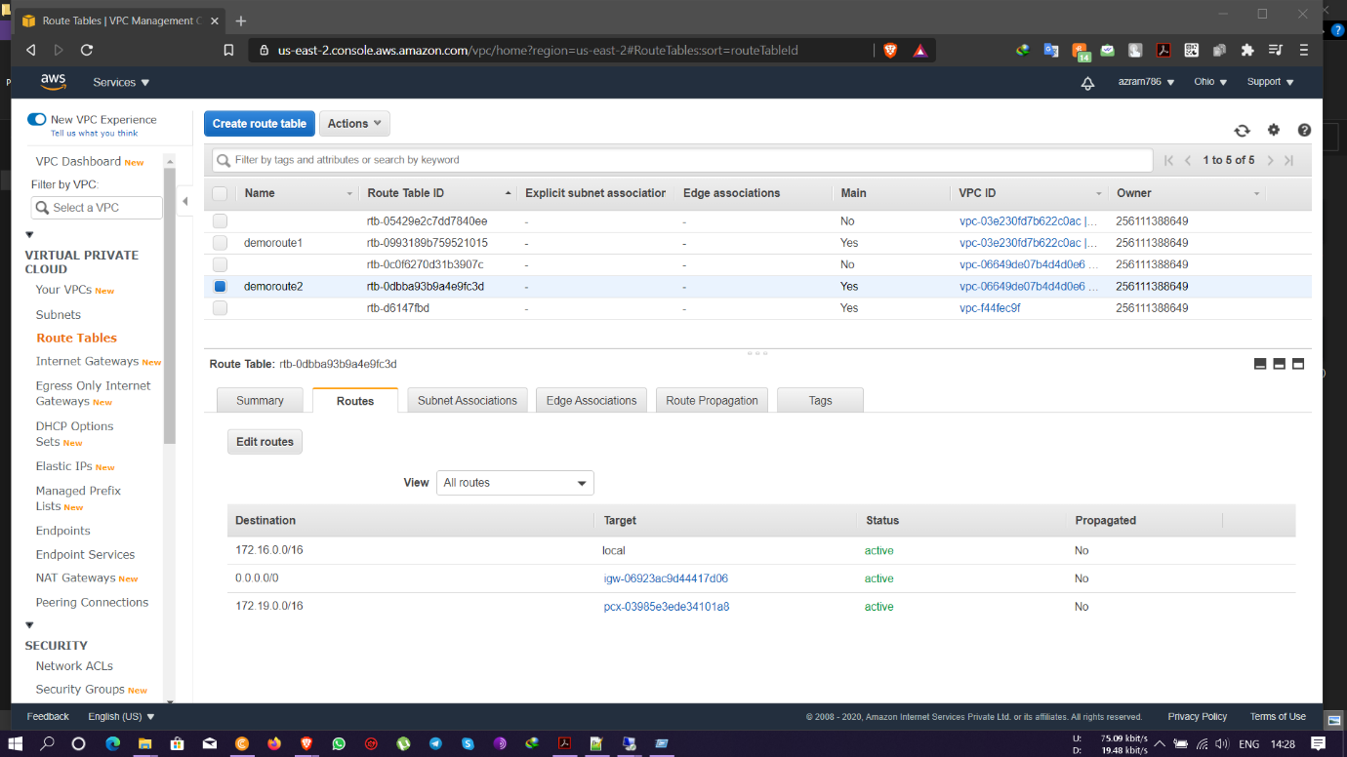

Ss: success for of ping request for private IP’s

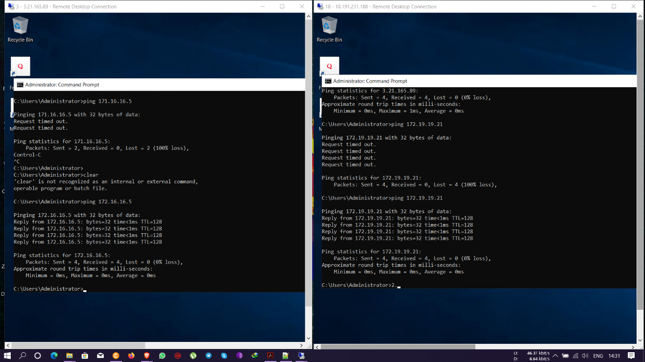

**Project 2:**

**IAM**

Task 1: Creating users without permissions- IAM password policy check.

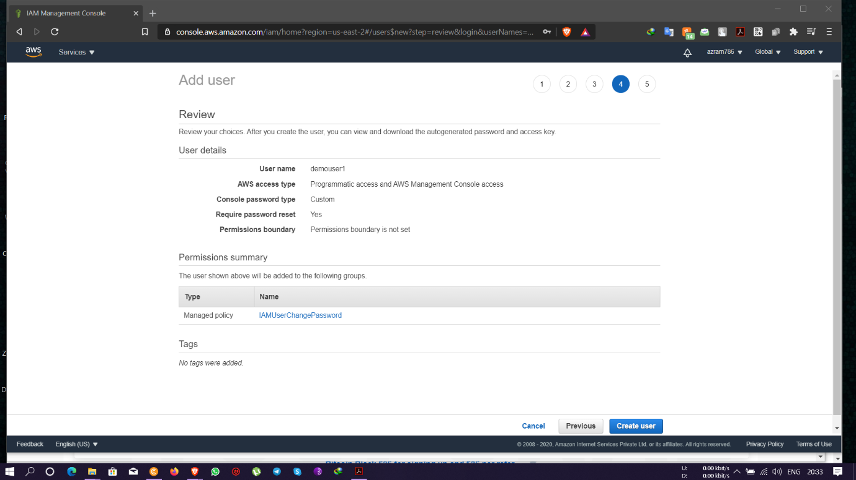

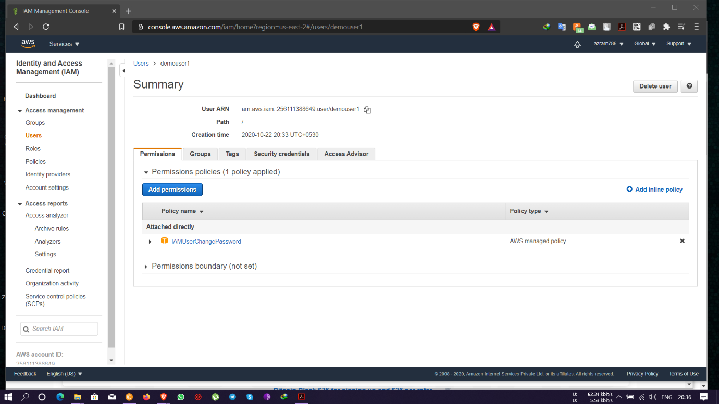

Task 2: Creating users without the IAM password policy.

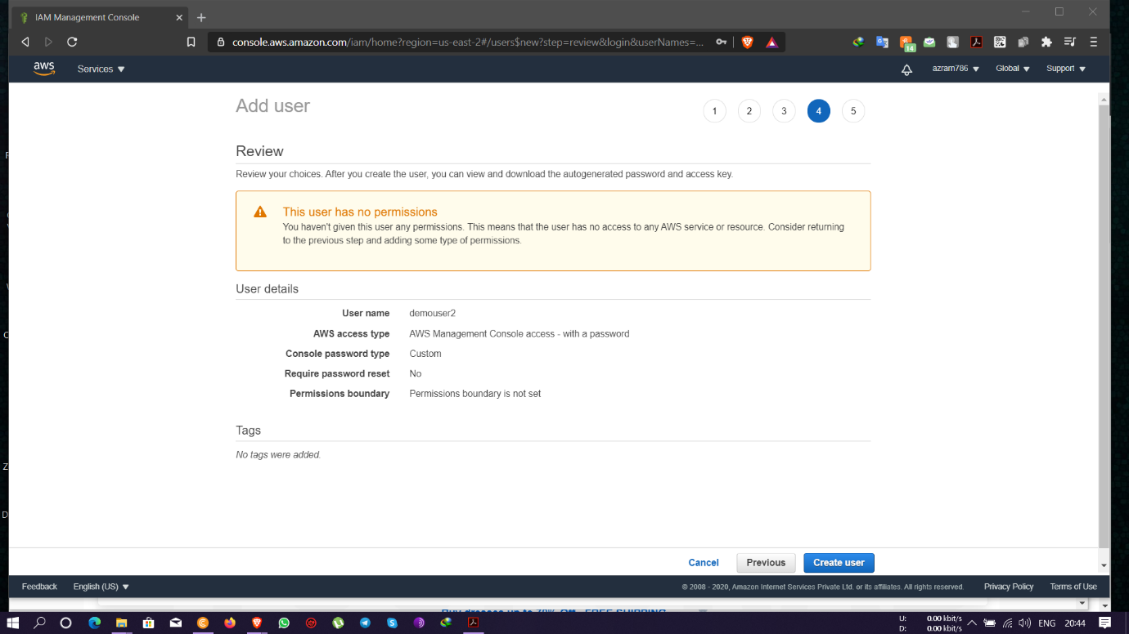

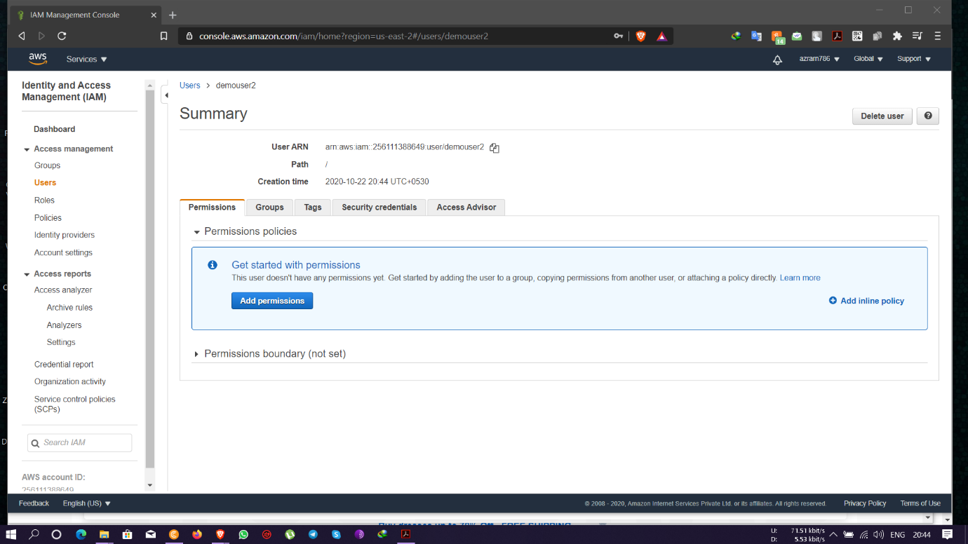

Task 3: Create a user with S3 full access

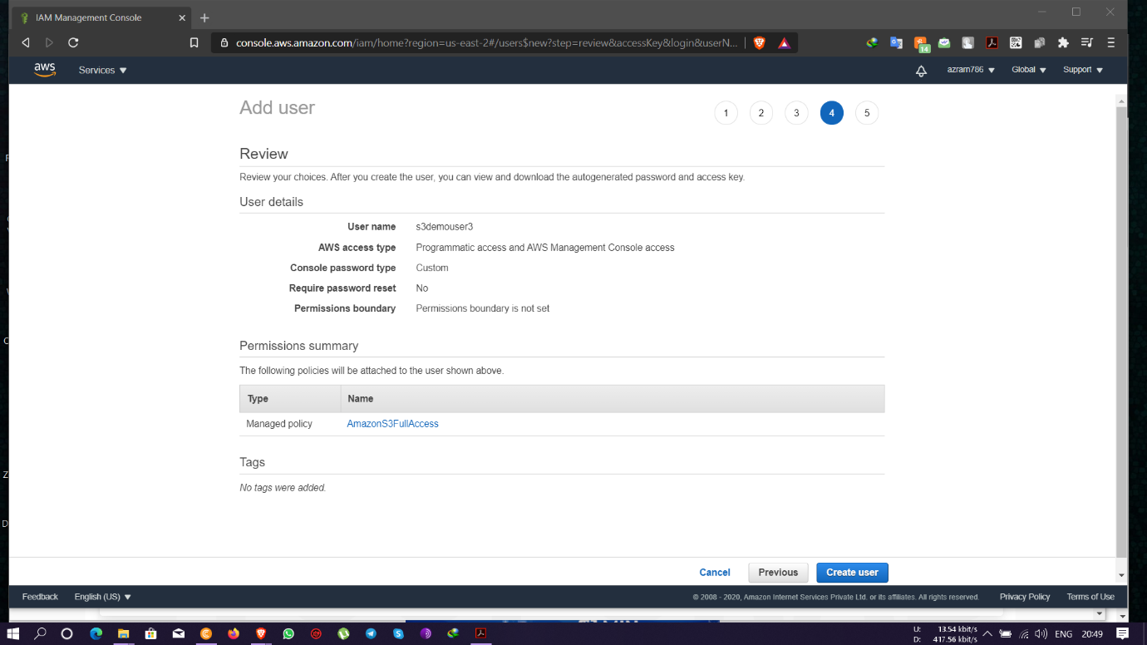

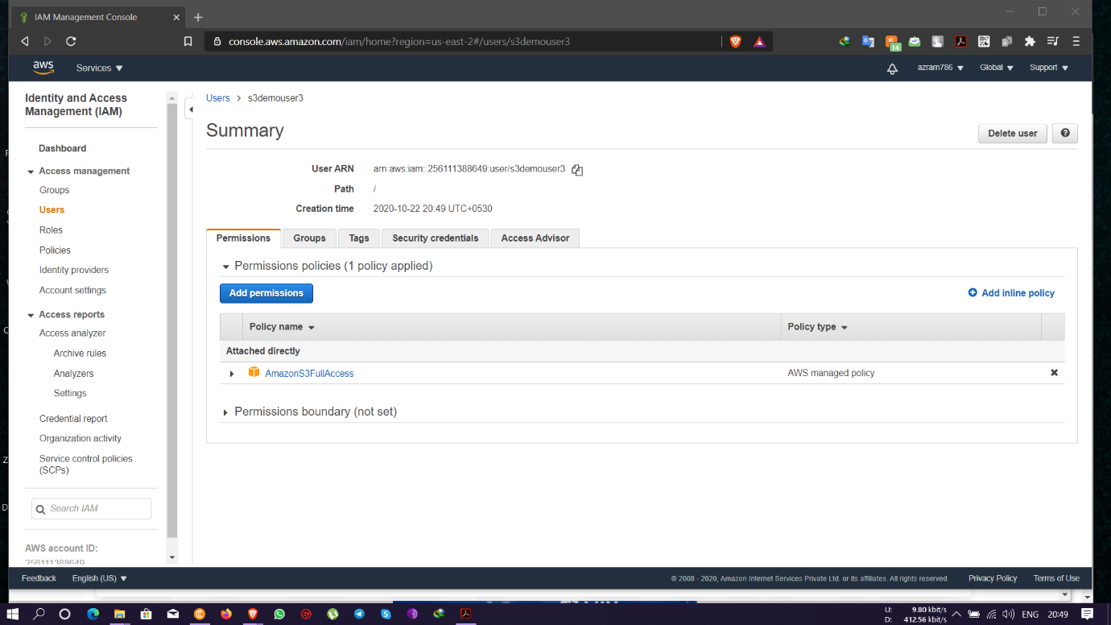

Task4: Create a group with ec2 full access

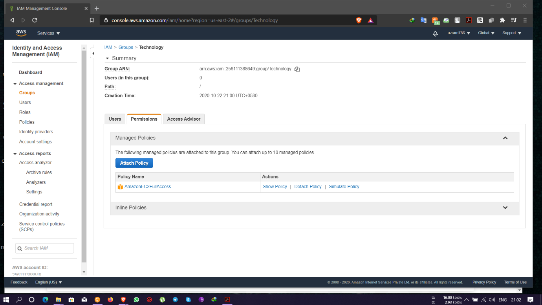

Task 5: Add user to a group and check if user policy and the group policy is reflecting on the user

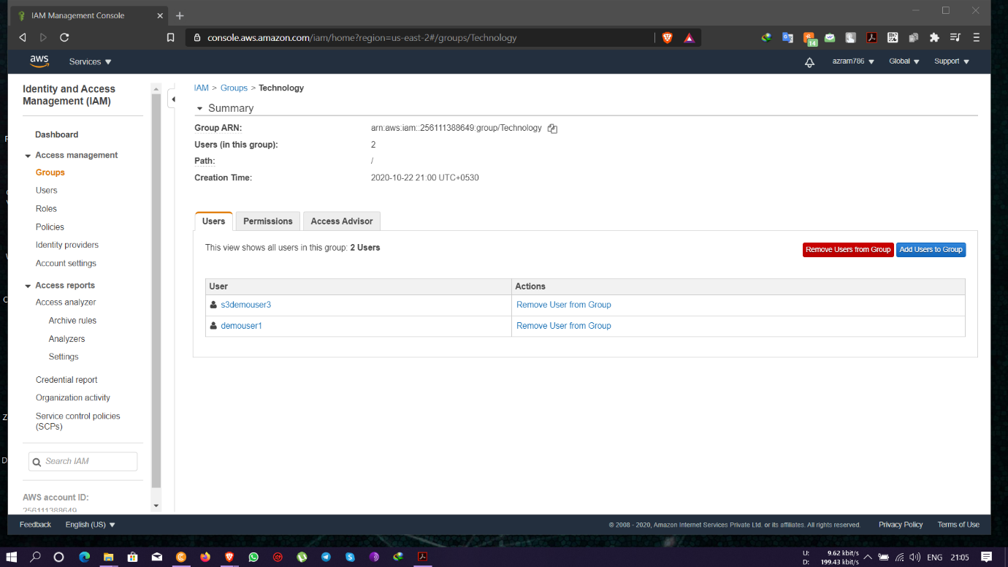

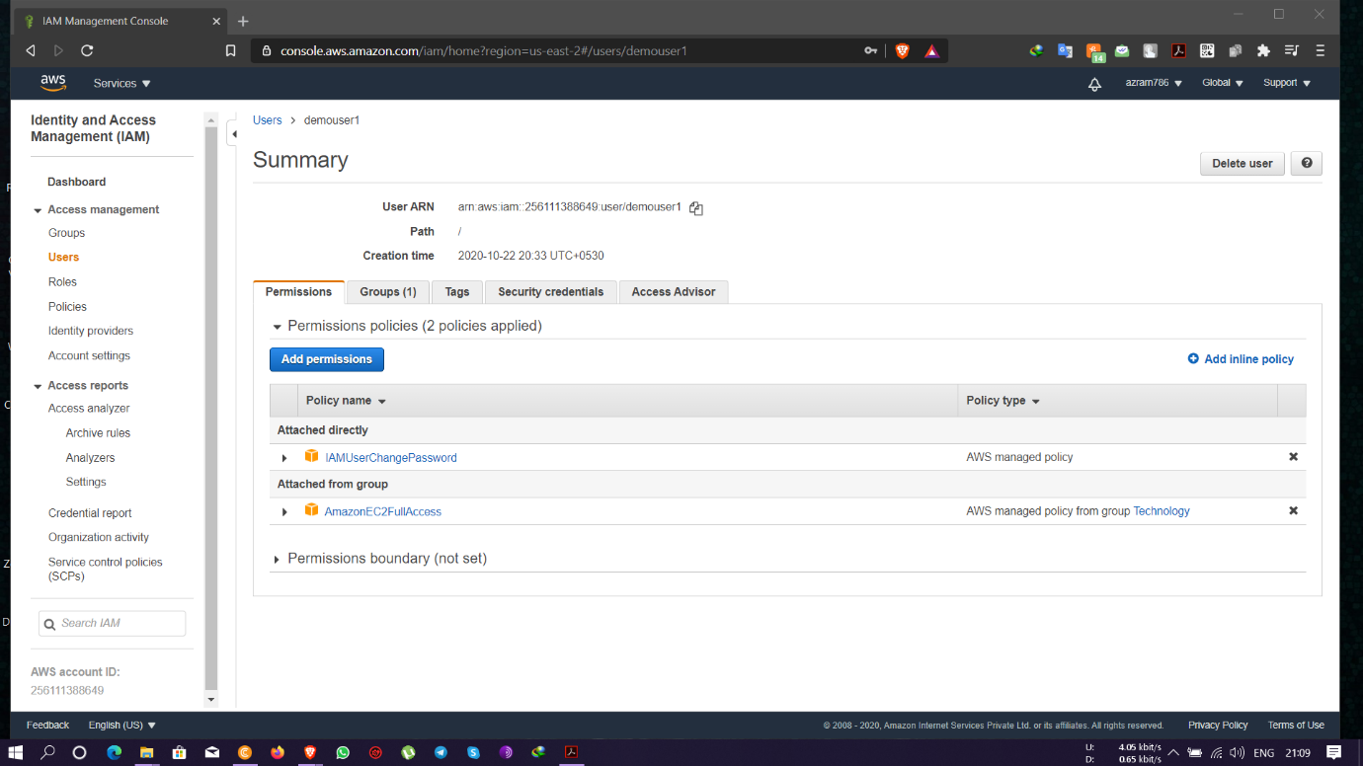

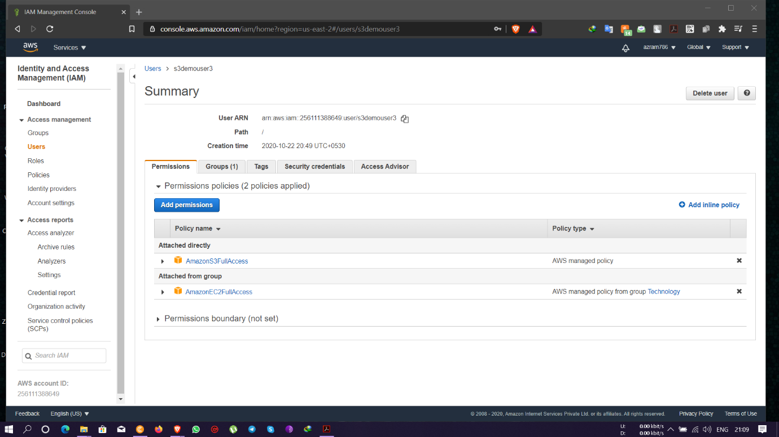

* User- demouser1 has permission for ec2 instances

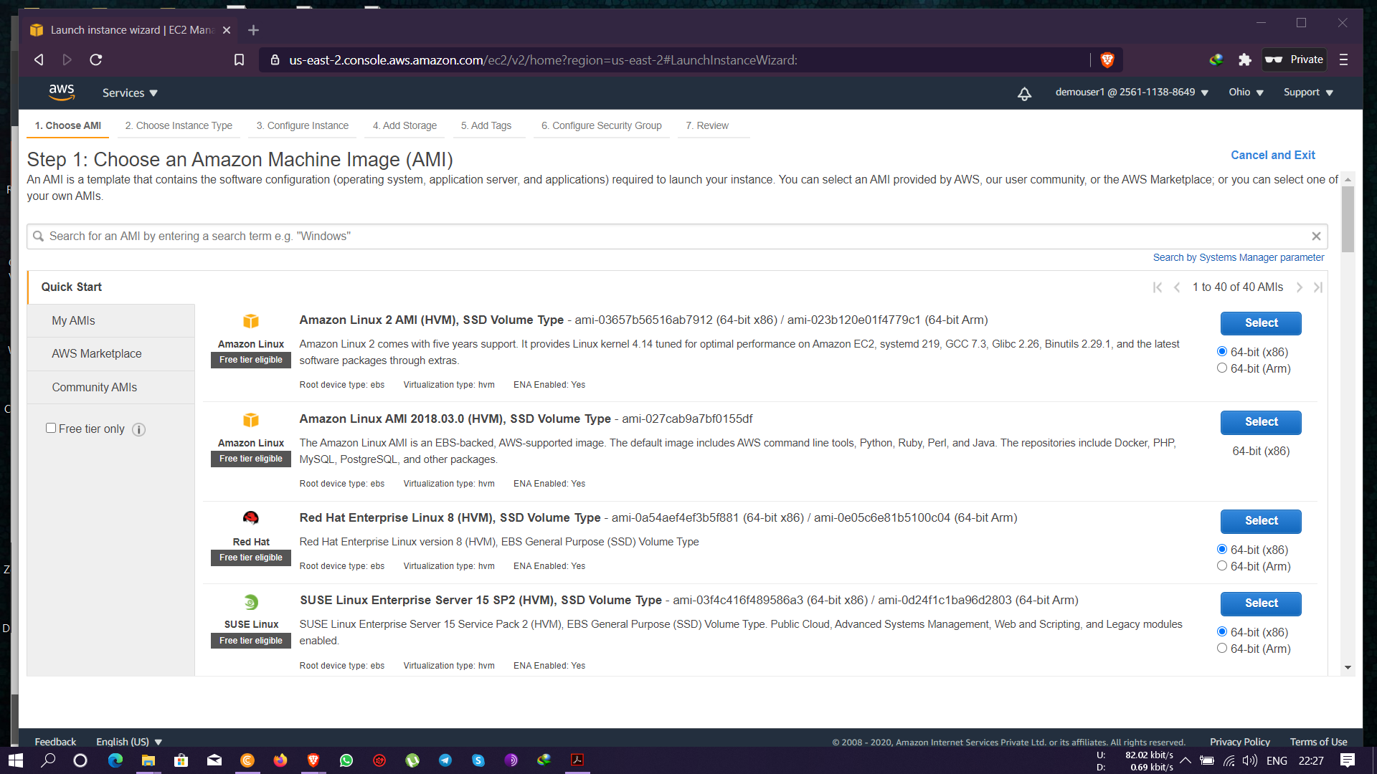

* User- demouser1 does not have permission for s3 buckets

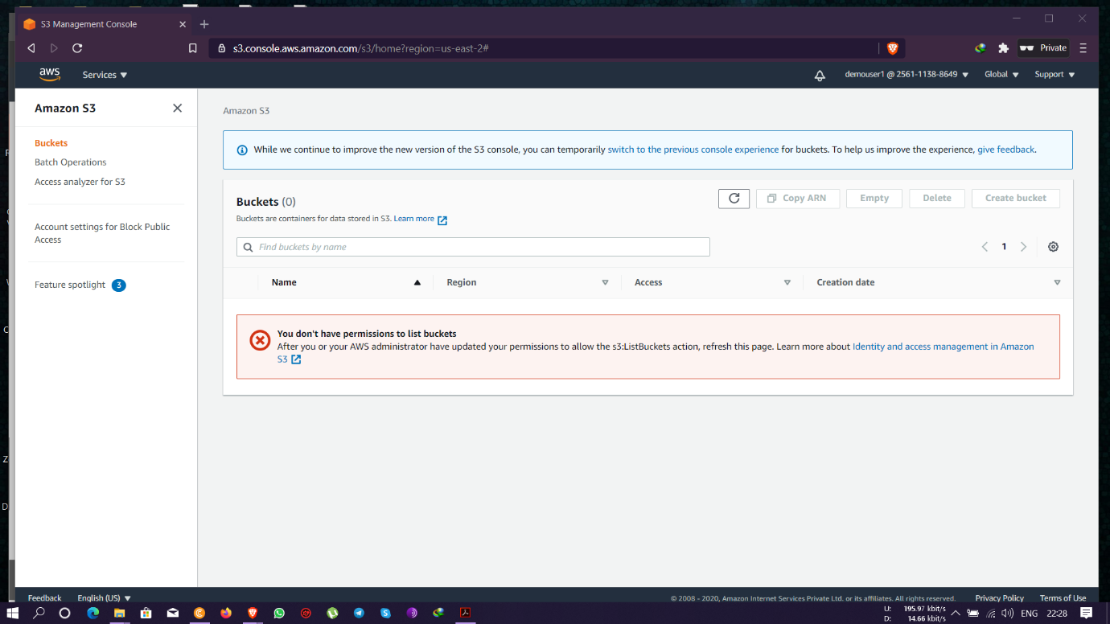

* User- demouser3 has permission for ec2 instances

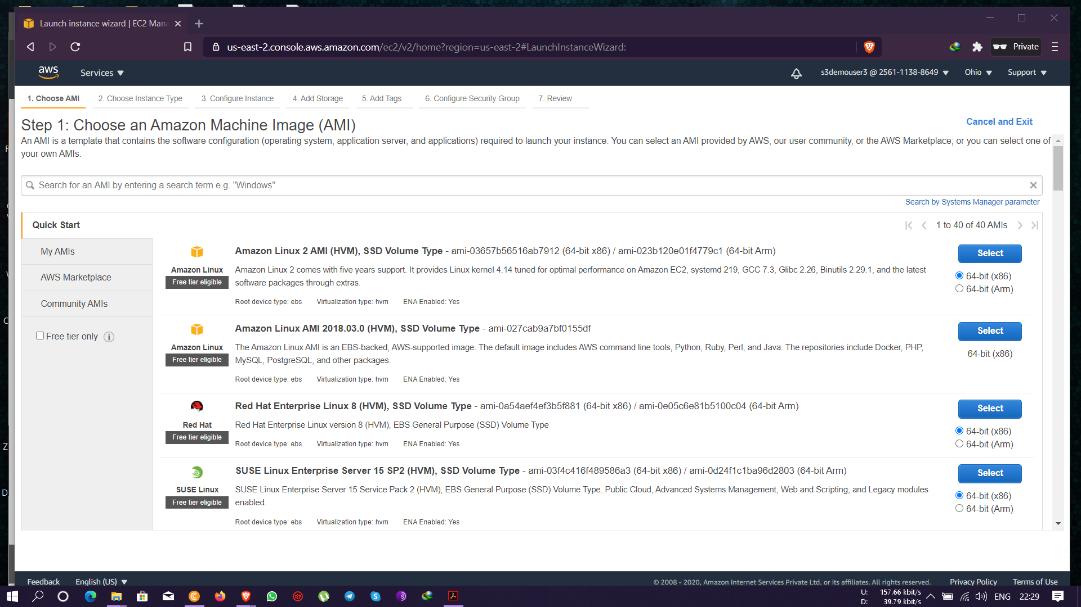

* User- demouser3 have permission for s3 buckets too.

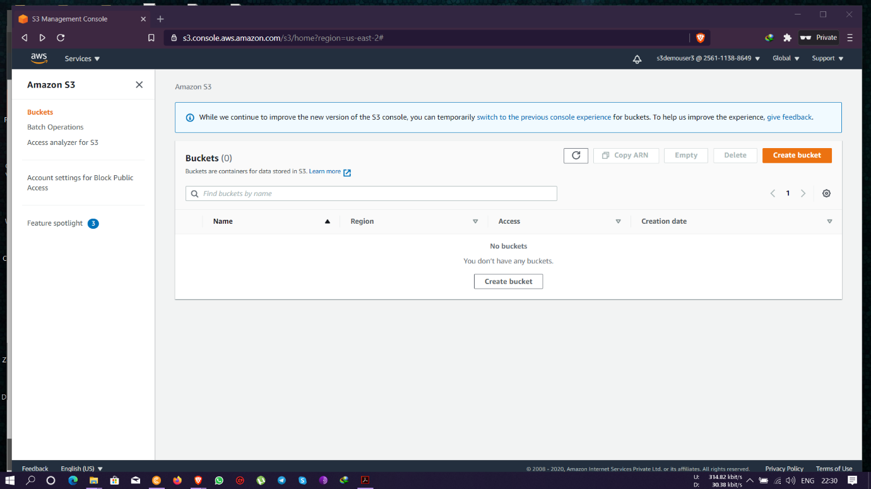

Task 6: Copy policies from the existing user

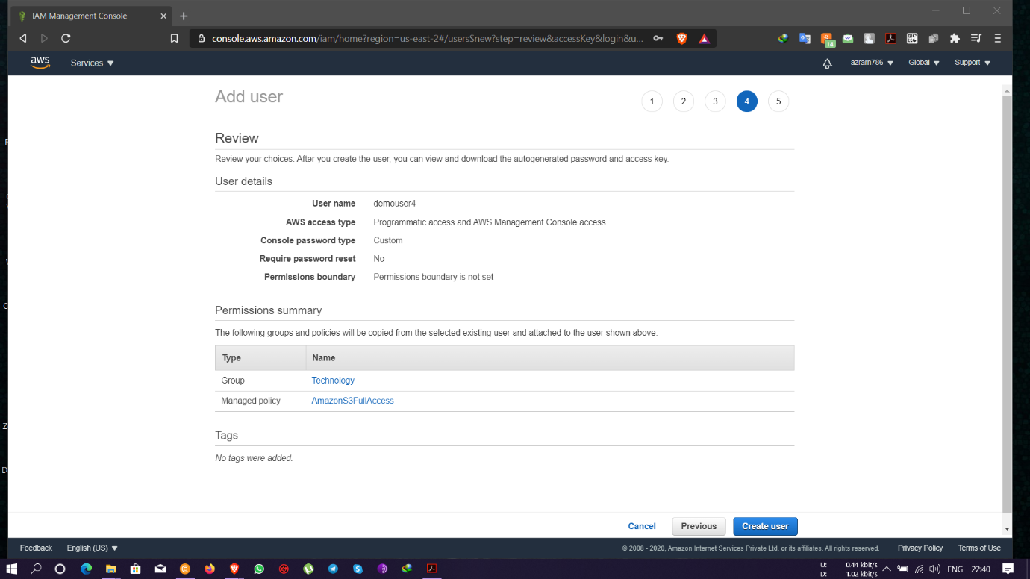

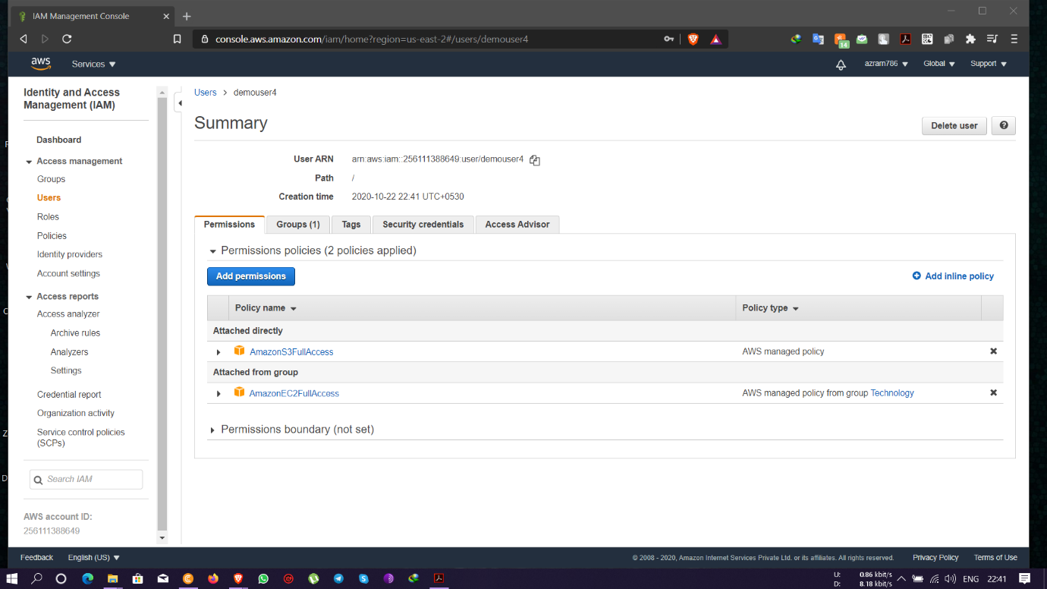

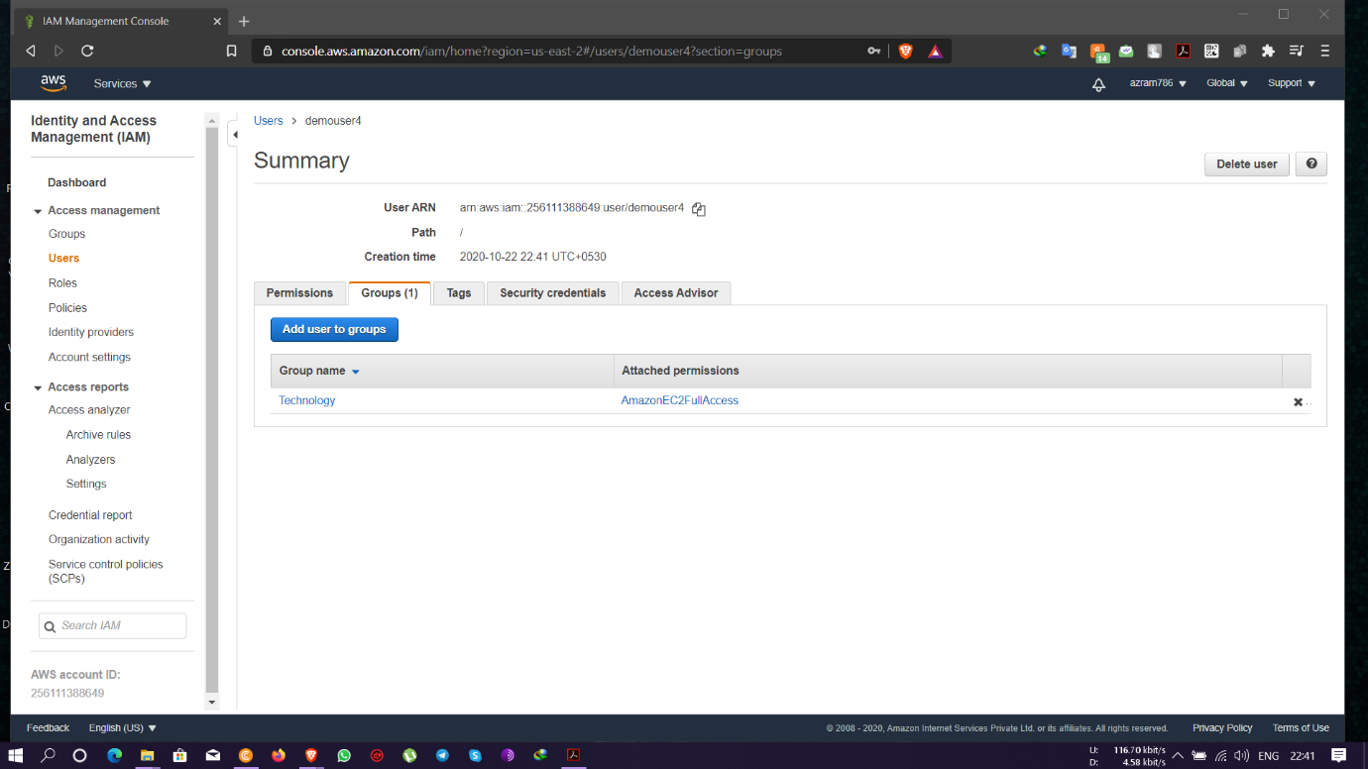

* User- demouser4 has permission for ec2 instances

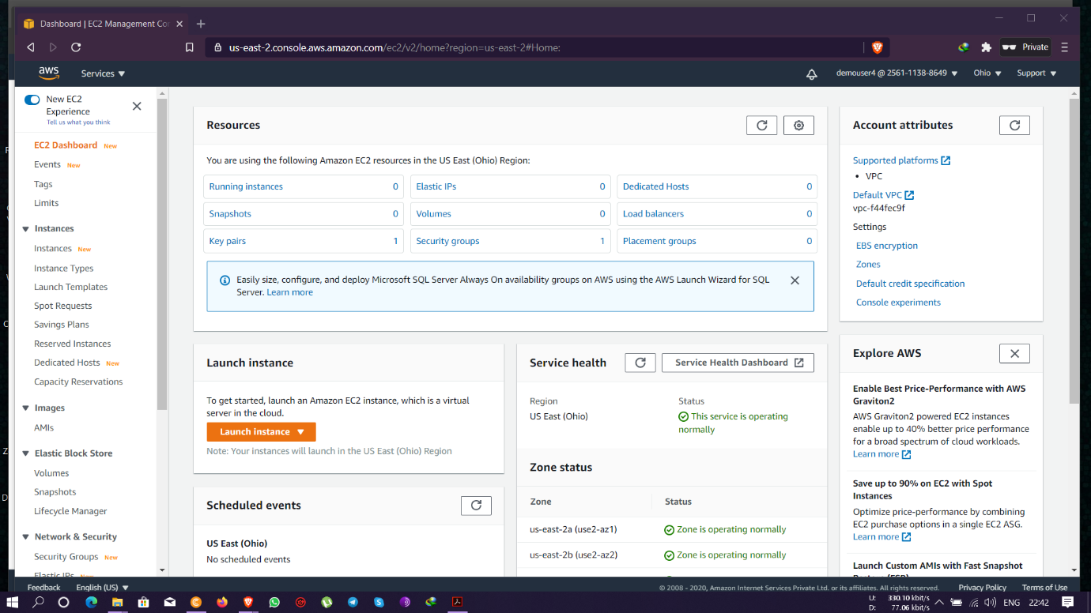

* User- demouser4 have permission for s3 buckets too.

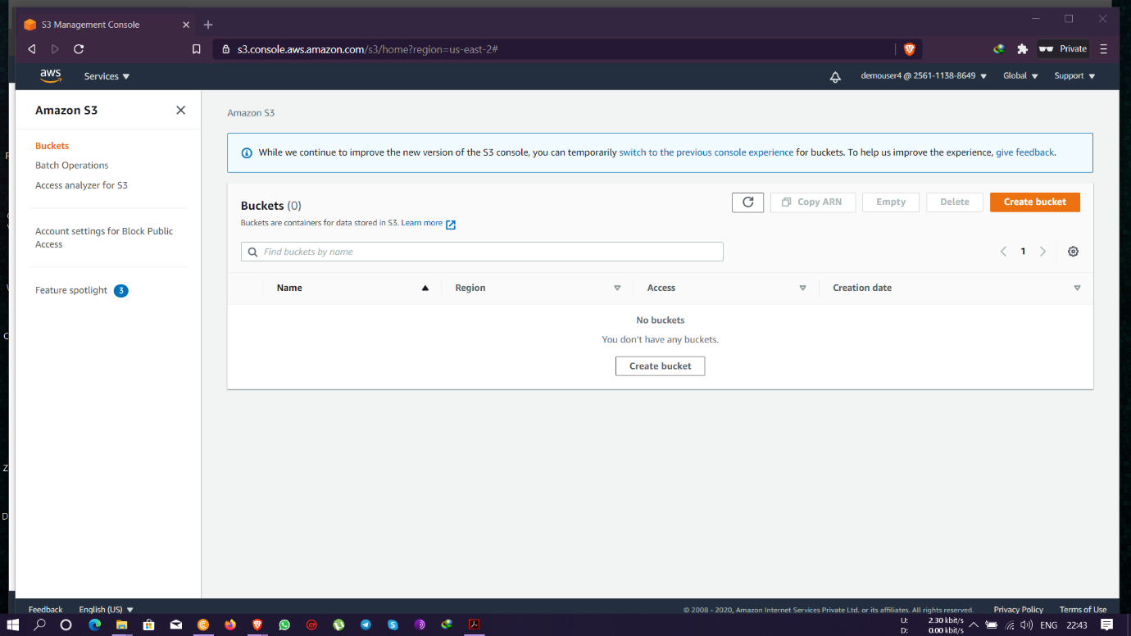

Task 7: Add user to a group in the process of creating a user

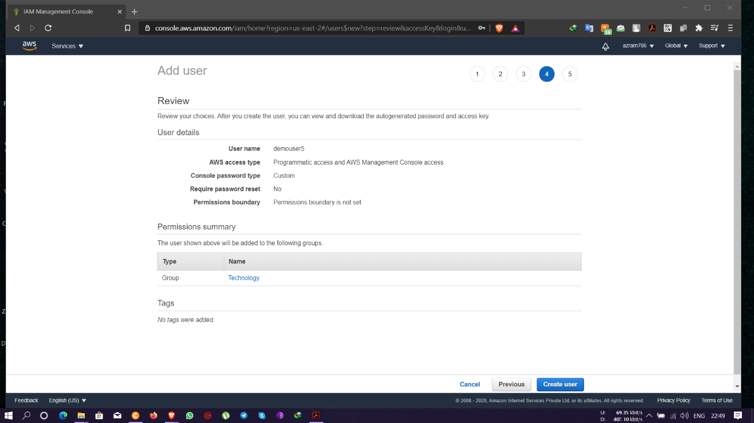

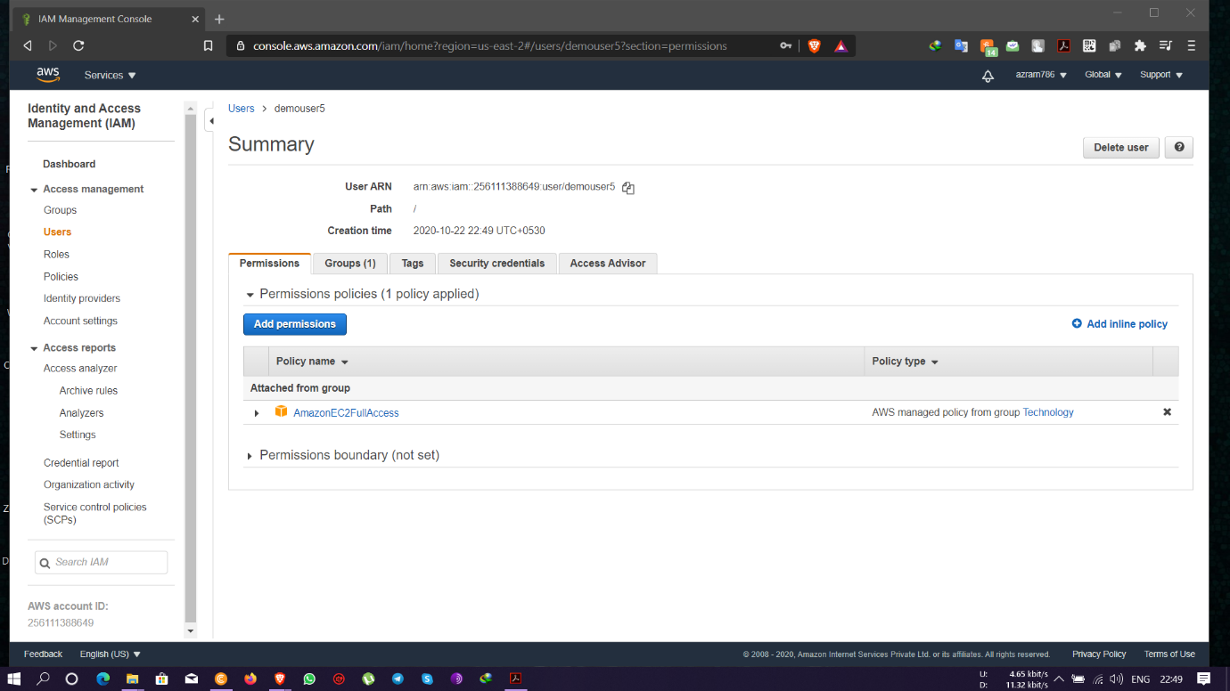

Task8: setting a password policy

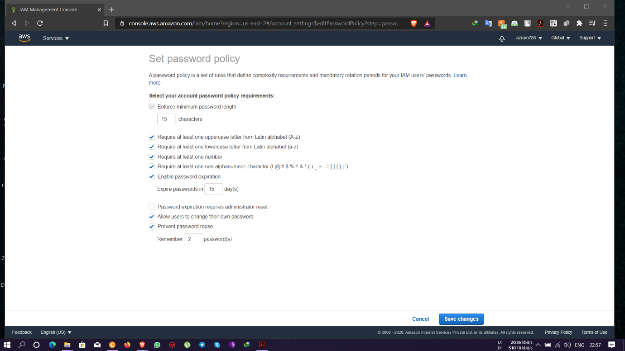

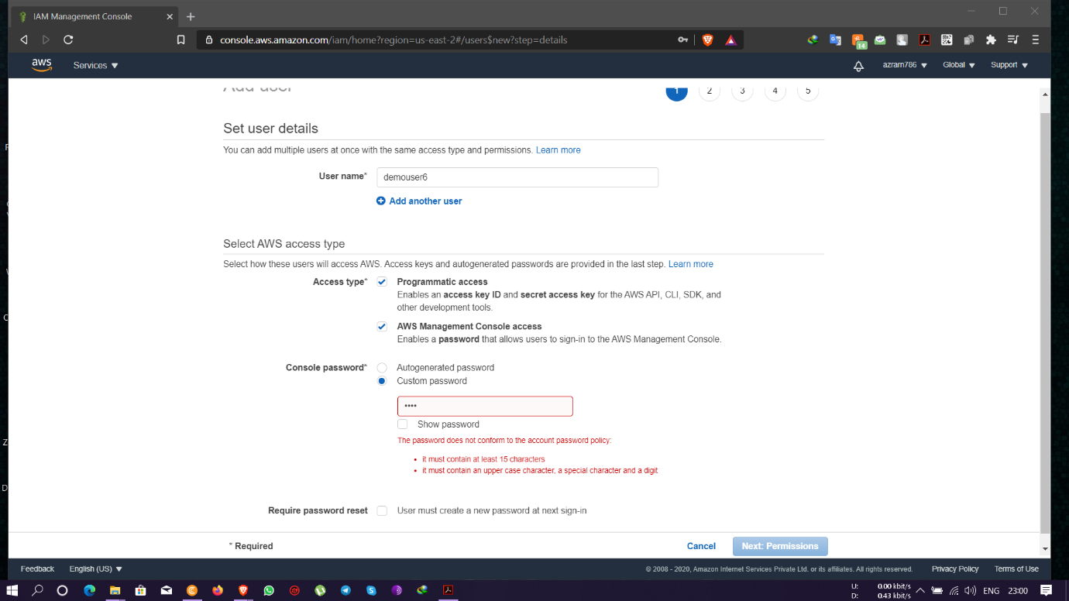

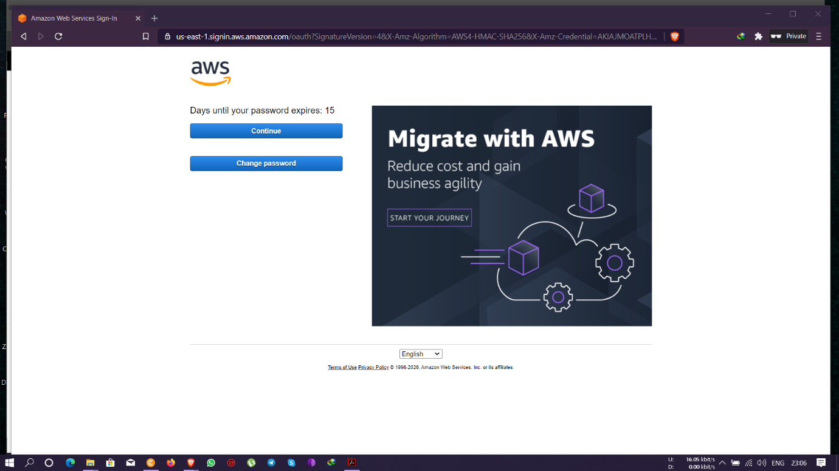

Task 9: Enabling MFA and using an MFA device

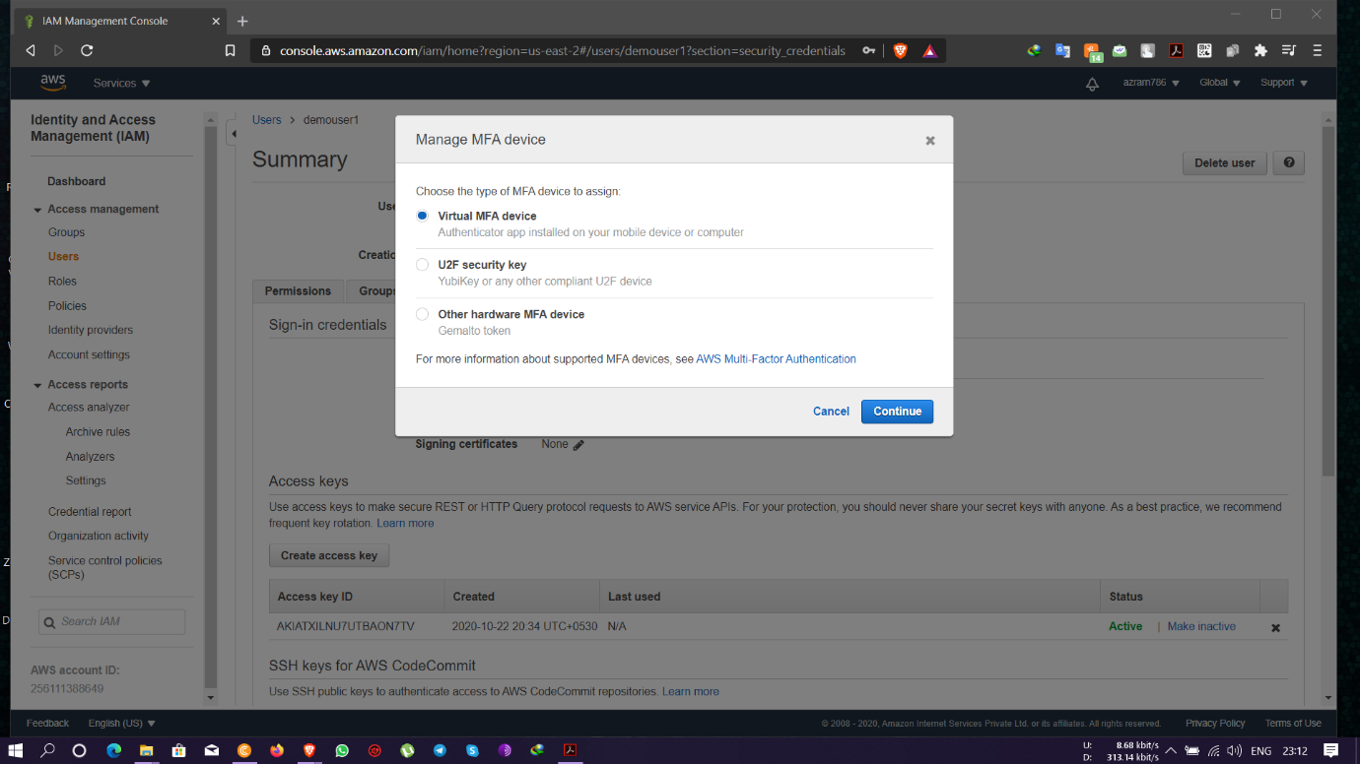

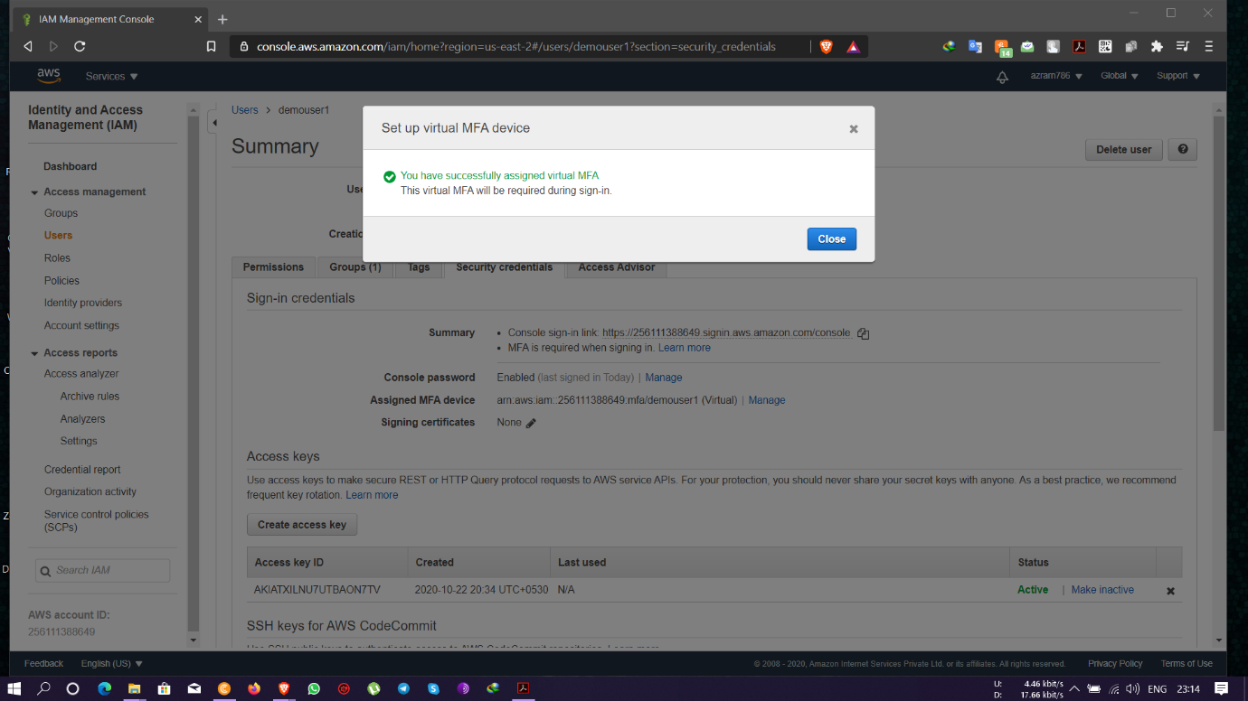

-login screen for MFA

